High Level Architecture

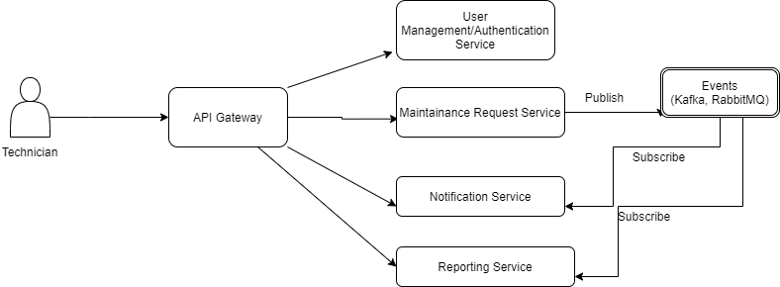

After authentication, Technician can interact with Maintenance Request service to close/register/reassign maintenance request. Each operation will publish an event which will be subscribed by Notification and reporting service.

Notification service will send the notification to target audience and reporting service will maintain a log for transaction for reporting purpose.